ePrescribe from a Phone Message – Nurse and Provider

When a Nurse or Provider receives a call from a patient for a prescription, the following steps are to be followed:

Communicate a Message from the Message Center. (Note: You MUST do this from the Message Center)

- Select Message Center:
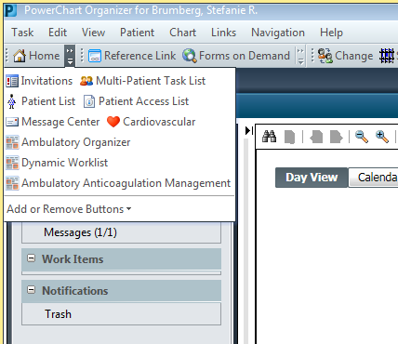

- Communicate, Message:
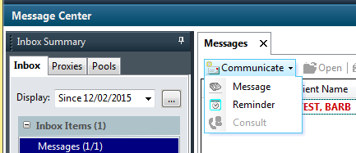

- Change the Subject of the Message to the appropriate office’s “Rx” Message Type and then select the binoculars next to patient name field:

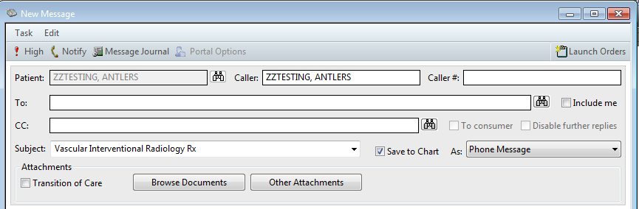
2
1

- If the patient does not have a “Phone Message” encounter type, Add Encounter:

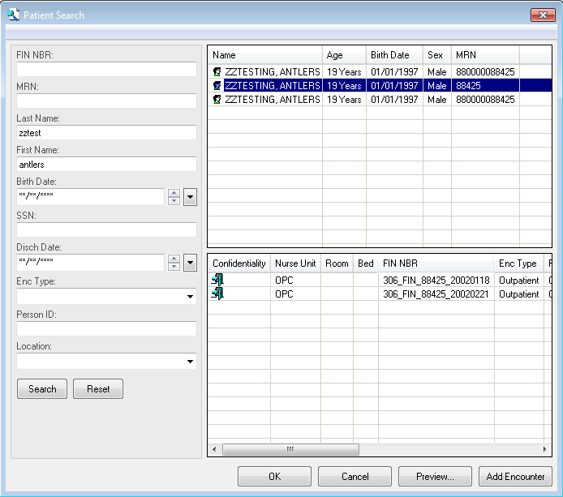

- Enter the AmbPhoneMsg Facility. Type AmbPh and hit Enter to select the Facility. Click Ok:
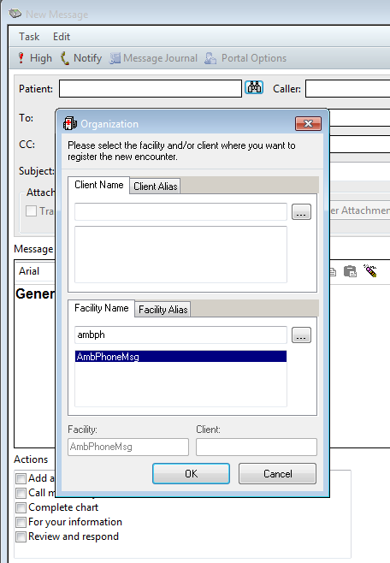
2
1

- Click Ok:
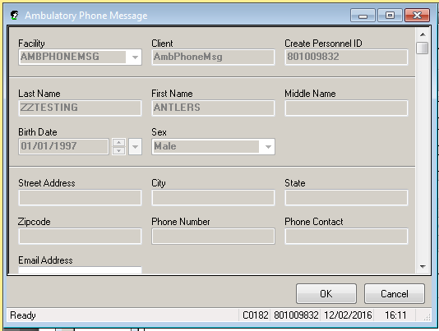

- This will take you back to the Message screen. On this screen, click Launch Orders:
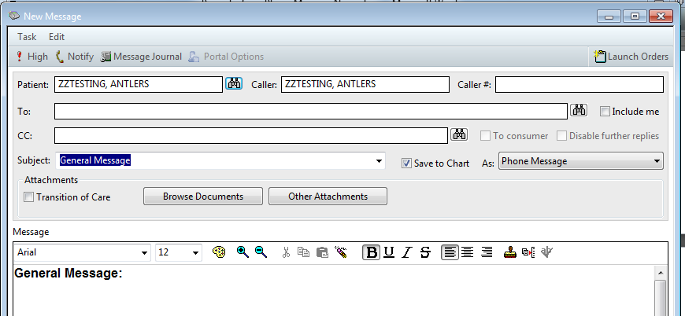

- On the orders screen, click on Add:
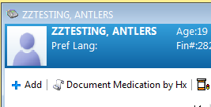

- Verify Ambulatory (Meds as Rx) is selected in drop down box:
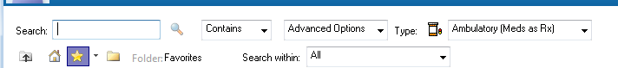

- Search for the Medication to be prescribed.

- Nurse Only:
Enter the patient’s physician and select the appropriate Communication Type:

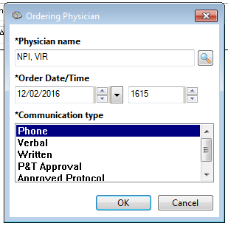
2
3
1

- Finish entering the prescription. If the pharmacy is not presented, enter it by clicking on the drop down arrow next to Send To and select “Find pharmacy”:
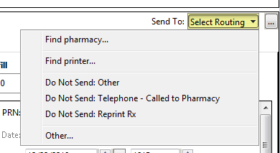

- Enter the patient’s pharmacy. (Note: entering State and Zip Code will narrow down the selections)
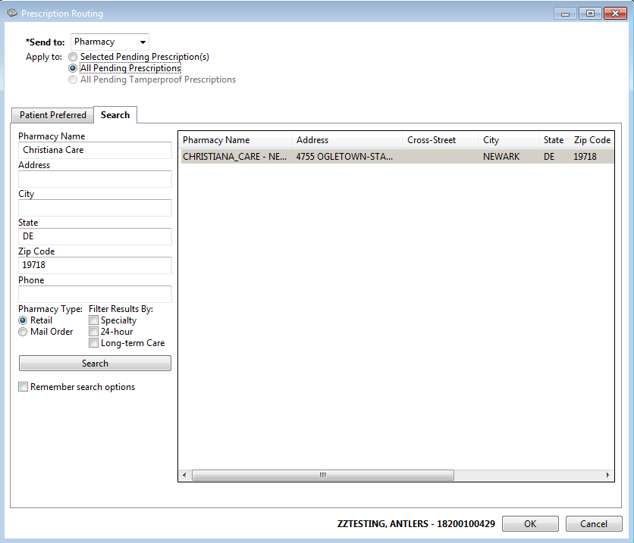

- When the order screen returns, click Sign:
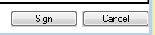

- On the next screen, verify the ePrescribed Med and Sign:

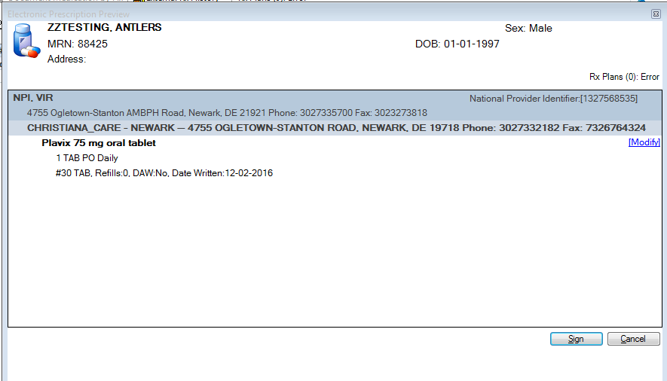

- Enter any additional detail under the Order details and click Send:
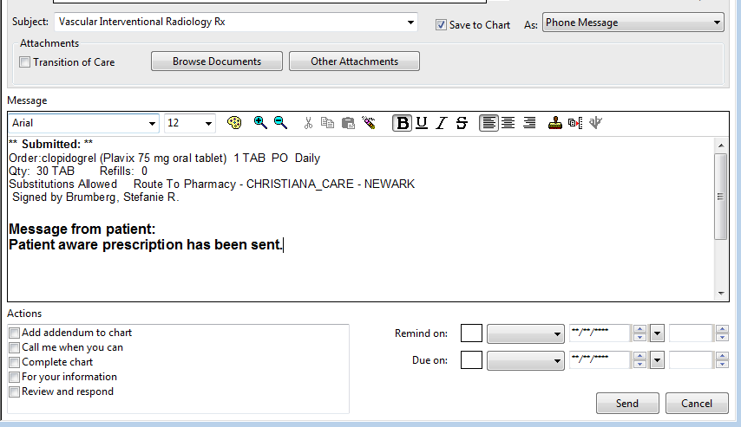
2
1

- If the Nurse created the Message, the Physician will see the Order in their Message Center as an Order to Approve.

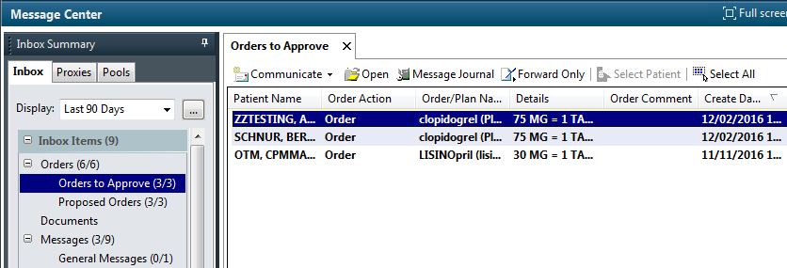

- Physician: Open the Message and either Approve or Refuse the order and Click Ok. If refused, pick up the phone and call the Pharmacy to cancel the prescription: 