**Procedure list search options expanded**

**Tips to easier searching:**

* Set filter to ‘contains’

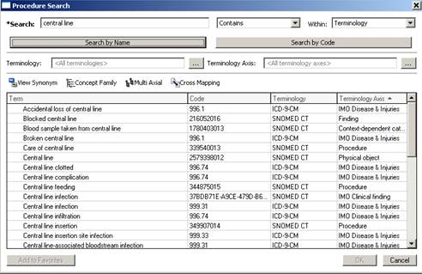

**Common procedures:**

* **Search Central line**

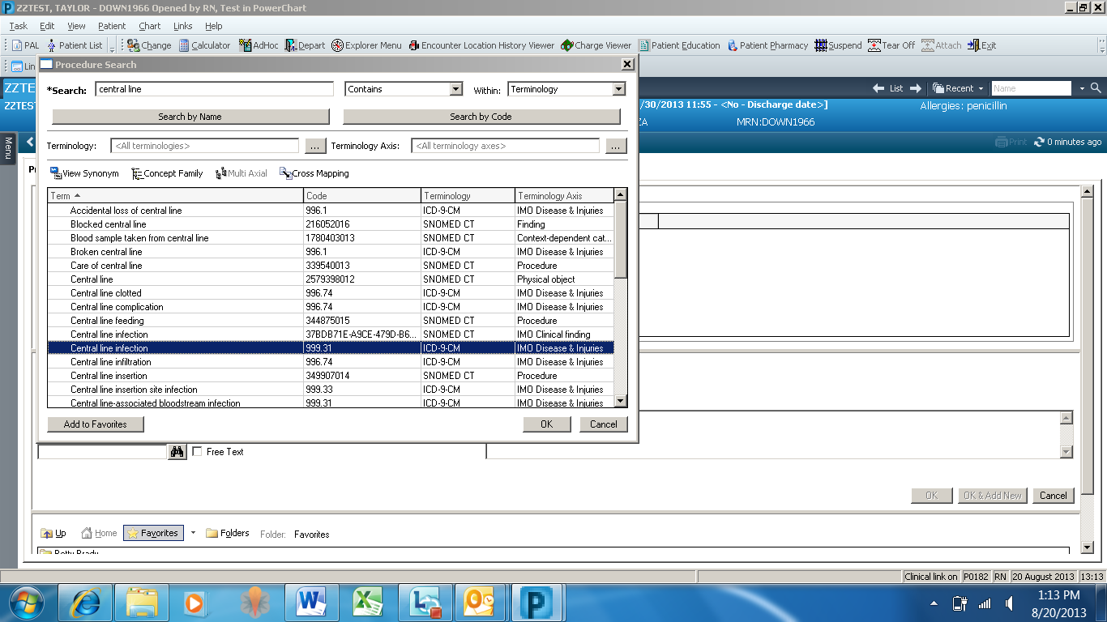

* **Search** **Arterial Line**

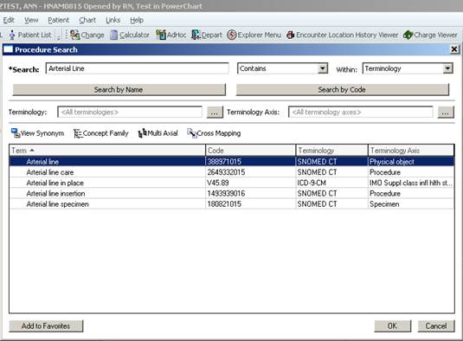

* **Search removal of joint prosthesis, scroll down**

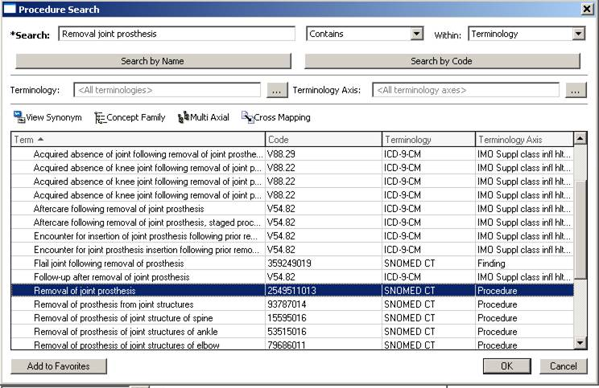

* **Utilize Add to Favorites: Highlight row and add**

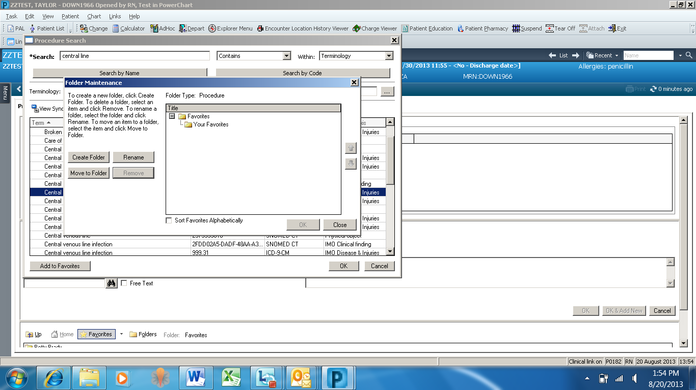

* **From the Procedure screen click on Favorites to open your favorites folder**

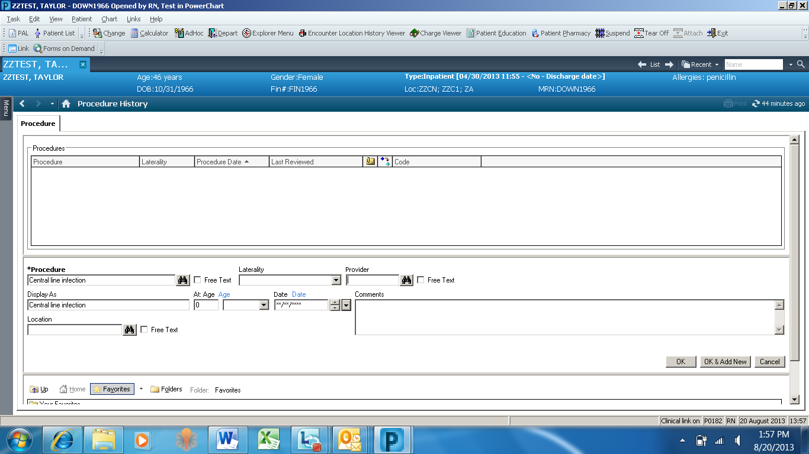

**I&O graph is back!**

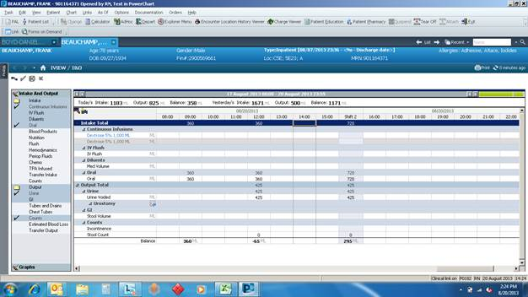

**Click on Graphs**

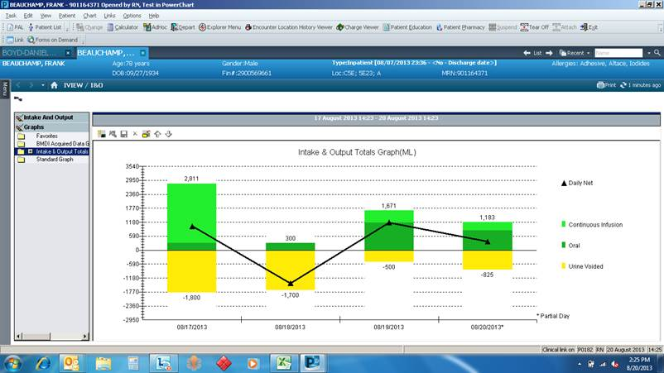

**Dates** **Color coded Legend**

**Intake** graphs above the zero line

**Outputs** display below the zero line

JGG