Beginning March 16, 2015, new features in PowerChart will enhance your experience in Documentation Workflow/ specialty workflows and make reviewing information from external documents a simple, electronic task.
Enhancements include:
- Dragon Upgrade
- Ability to Review Patient External Documentation

Dragon Upgrade
In early March, an upgrade was taken to fix issues with cursor jumping, line spacing and cursor stability while using Documentation Workflow.

Reviewing Patient External Documentation
Christiana Care can now accept secure clinical documentation from other health care facilities. These secure documents will be received by the HIMS department and matched with a Christiana Care patient record. Once matched, physicians can review the documentation in the patient’s chart.

How Will I Know If There Are External Documents Available?
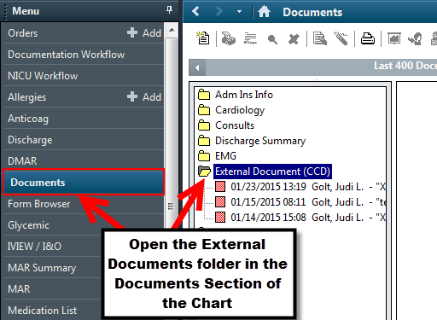
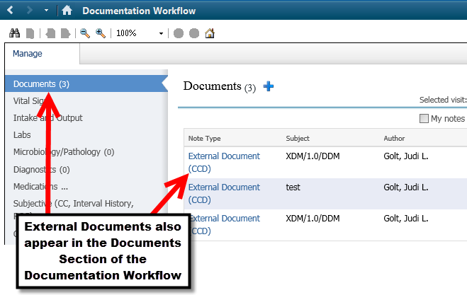
You will see the external documents in the patient’s chart on Documentation Workflow under Documents. You can also see them in the Documents Menu under External Documents (CCD) folder .

Opening the Secure Documentation
- Open the Patient’s Chart.
- Locate the Note Type External Document (CCD) in either of the following locations:
  - Documentation Workflow, under Documents
  - Documents Menu, External Document (CCD) folder
- Double click on the Document to open it.
- In Document Viewer, under Attachments, click on the attachment with the file extension “.xml”.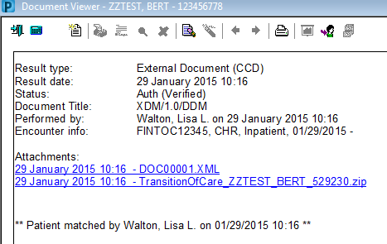
- The document will open so you can review the information provided. 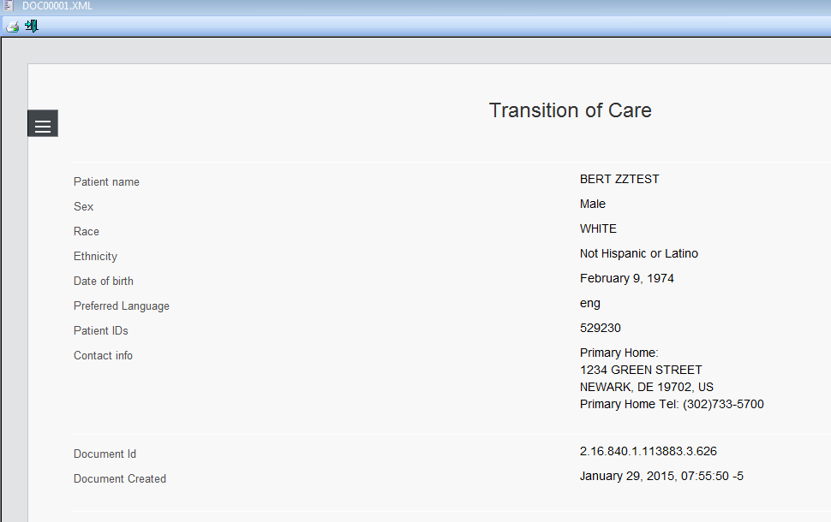

Coming soon!
In addition to reviewing the external documentation, you will soon have the ability to compare and update Problems, Allergies, Medications and Immunizations with the current Christiana Care record for that patient.
Look for communication regarding this enhancement in the near future!

