Selecting Brief Op Note
When completing Brief Op Note, after clicking on the “Add Document” icon,
click “B” and Brief OP Note will display. Click in the body of the note and then click to required fields or scroll to desired section of note.
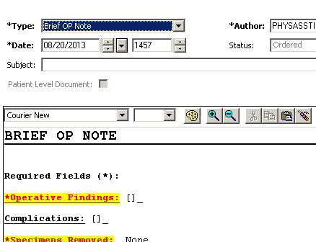
If you scroll before you click in the note, you will get this message.
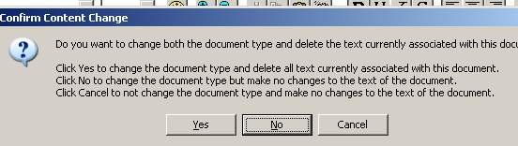
Click “cancel” to return to the Brief Op note. Click in the body of the note and continue completing your note. Click “Sign” when finished.

